Dear Students,
Congratulations on choosing to take IB Chemistry! This course is a challenging yet rewarding journey that will deepen your understanding of the natural world and strengthen your analytical skills. To ensure you get off to a strong start, here are some key tips to help you prepare for the year ahead.
Strengthen Your Foundations
IB Chemistry builds on fundamental concepts from previous chemistry courses. Before the school year begins, review essential topics like nomenclature (naming), balancing reactions, atomic structure, reaction types, predicting products, bonding, and thermodynamics (endothermic/exothermic, energy profile diagrams).
If you want to try and get ahead of the game this summer, I recommend watching the following video by TheOrganicChemistryTutor:
https://www.youtube.com/watch?v=74-X94OP2XI
This video demonstrates how to do basic mole conversion calculations, which is something we will be doing a lot of during the course!
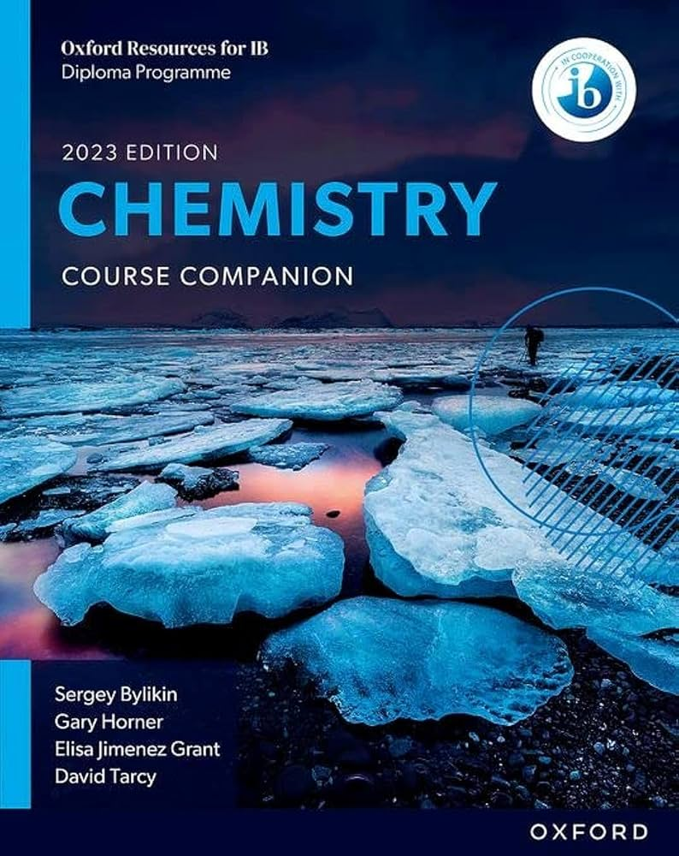
Resources:
Textbooks
The main textbook that the IB Chemistry course will be based on is the 2023 edition of the Oxford Chemistry Course Companion. Digital copies of this textbook, along with the Pearson edition and the Hodder edition as extra resources, will be provided to you. However, if you prefer a paper copy, it is recommended that you purchase your own copy of this textbook from a used bookstore or Amazon. There will be paper copies available to borrow, but only in year 2 (grade 12).
Online Resources
Here are a couple of great IB YouTube channels you can check out to get ahead:
https://www.youtube.com/@ibchemvids
https://www.youtube.com/@siriusrevision
https://www.youtube.com/@TheOrganicChemistryTutor
https://www.youtube.com/@tdewitt451

Develop Strong Study Habits
IB Chemistry requires consistent effort. Here are some habits that successful students follow:
- Practice regularly: Work through problems to solidify your understanding.
- Create summary sheets (1 page double sided) for each unit.
- Stay organized: Keep your notes structured for quick reference.
- Understand, don’t memorize: Focus on grasping concepts rather than rote memorization.
Get Comfortable with Lab Work
Practical investigations are a big part of IB Chemistry. Refresh your lab skills by reviewing safety guidelines, common lab techniques, and data analysis methods. This will help you feel more confident during experiments.
Maintain a Curious Mindset
IB Chemistry isn’t just about formulas—it’s about understanding how chemistry impacts our world. Explore real-world applications through documentaries, articles, or even experiments at home to stay engaged with the subject. I recommend watching a few https://www.youtube.com/@NileRed videos!
Finally, don’t hesitate to ask questions and seek help when needed. Chemistry is best learned through discussion and collaboration. Your teachers and classmates are valuable resources, so make the most of them!
Wishing you a successful and exciting year ahead!
Mr. Easton
IB Chemistry Teacher
Brian.Easton@abbyschools.ca

