Dear Students,
Welcome to IB Mathematics: Analysis & Approaches! This course aims to develop your mathematical skills, understanding, and appreciation for math. To ensure you get off to a strong start, here are some key tips to help you prepare for the year ahead.
Strengthen Your Foundations
As there is a non-calculator portion of the course, it is essential for you to work on your basic mathematical skills prior to the start of the school year. Some of these skills include:
- Use of addition, subtraction, multiplication, and division of integers and fractions
- Rounding of numbers
- Solving linear equations

Here are a couple of websites you can check out to help you to review the above skills:
- https://www.factmonster.com/math/flashcards
- https://www.free-training-tutorial.com/algebra-games.html
Note: Both websites are a little juvenile, but the concepts reviewed are worth it

Resources:
Calculators
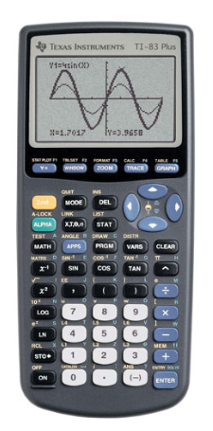

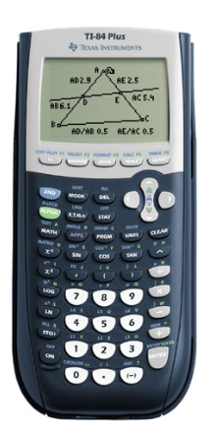
Although there is a non-calculator portion of the course, a graphing calculator is required for the other portion. As a result, it would be beneficial for students to purchase their own graphing calculator (TI-83 or TI-84 or CASIO fx-9750GIII). These are available at Staples, Best Buy, or Amazon. There will be some available to students to use during class time, but they will not be able to be used outside of the classroom.

TI-83 TI-84 CASIO fx-9750GIII

Other Online Resources
Here are a couple of other great websites you can check out to get ahead:
- Khan Academy: https://www.khanacademy.org/
- Revision Village: https://www.revisionvillage.com/ib-math/analysis-and-approaches-sl/
- My Own Website with Access to Notes and Assignments: https://mrkeeleysclassroom.weebly.com/

Develop Strong Study Habits
Any IB course requires a consistent effort. Here are some habits that successful students follow:
- Practice regularly: Work through problems to solidify your understanding.
- Create summary sheets (1 page double sided) for each unit.
- Stay organized: Keep your notes structured for quick reference.
- Understand, don’t memorize: Focus on grasping concepts rather than rote memorization.
Finally, don’t hesitate to ask questions and seek help when needed. Mathematics is best learned through discussion and collaboration. Your teachers and classmates are valuable resources, so make the most of them!
Wishing you a successful and exciting year ahead!
Mr. M. Keeley
IB Mathematics Teacher
Michael.keeley@abbyschools.ca

